ESIGN Frontend

**Application code**

Bitbucket : <http://10.41.75.8:7990/projects/ESIGN>

**Jenkins :**

[**http://10.41.75.9:8095/jenkins/job/ESIGN/**](http://10.41.75.9:8095/jenkins/job/ESIGN/)

Here we can see esign frontend and esign backend

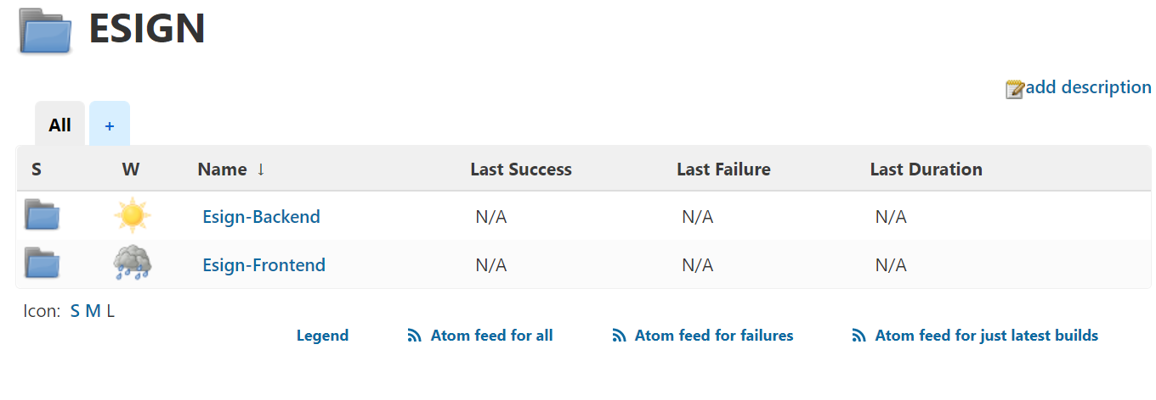

To build esign frontend go to **Esign-Frontend** folder

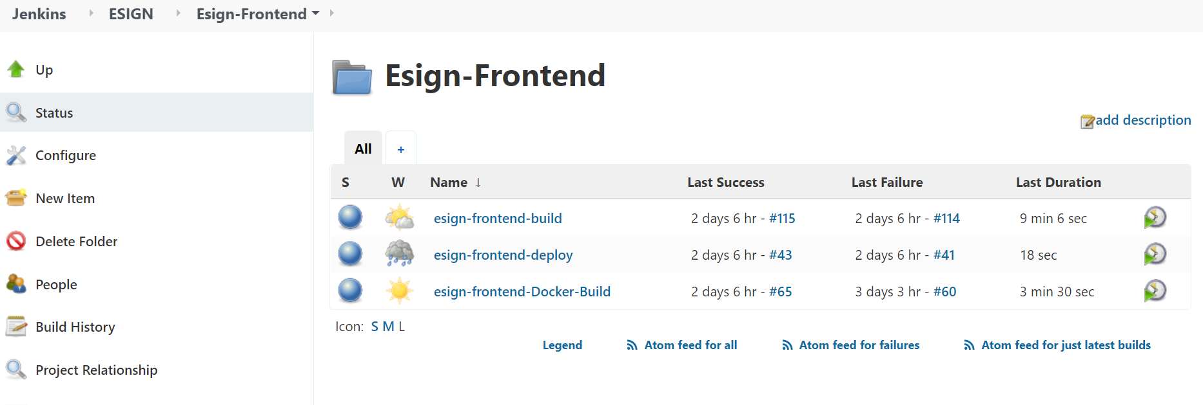

We are having three jobs, if the application team committed changes to bitbucket build the [esign-frontend-build](http://10.41.75.9:8095/jenkins/job/ESIGN/job/Esign-Frontend/job/esign-frontend-build/)

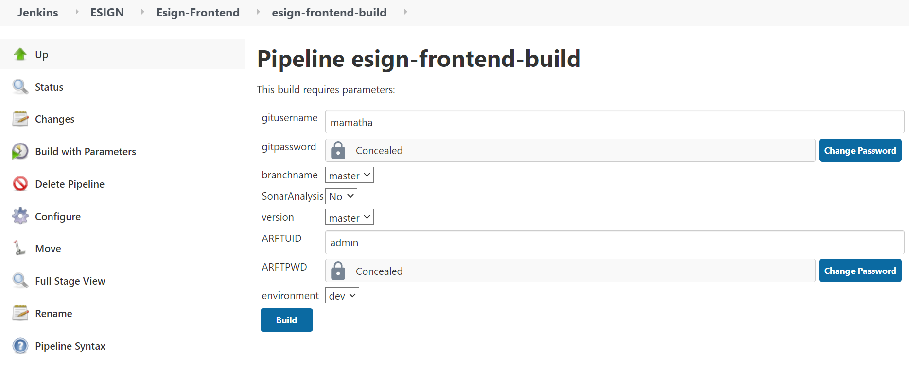

To build esign backend go to **Esign-Backend** folder trigger

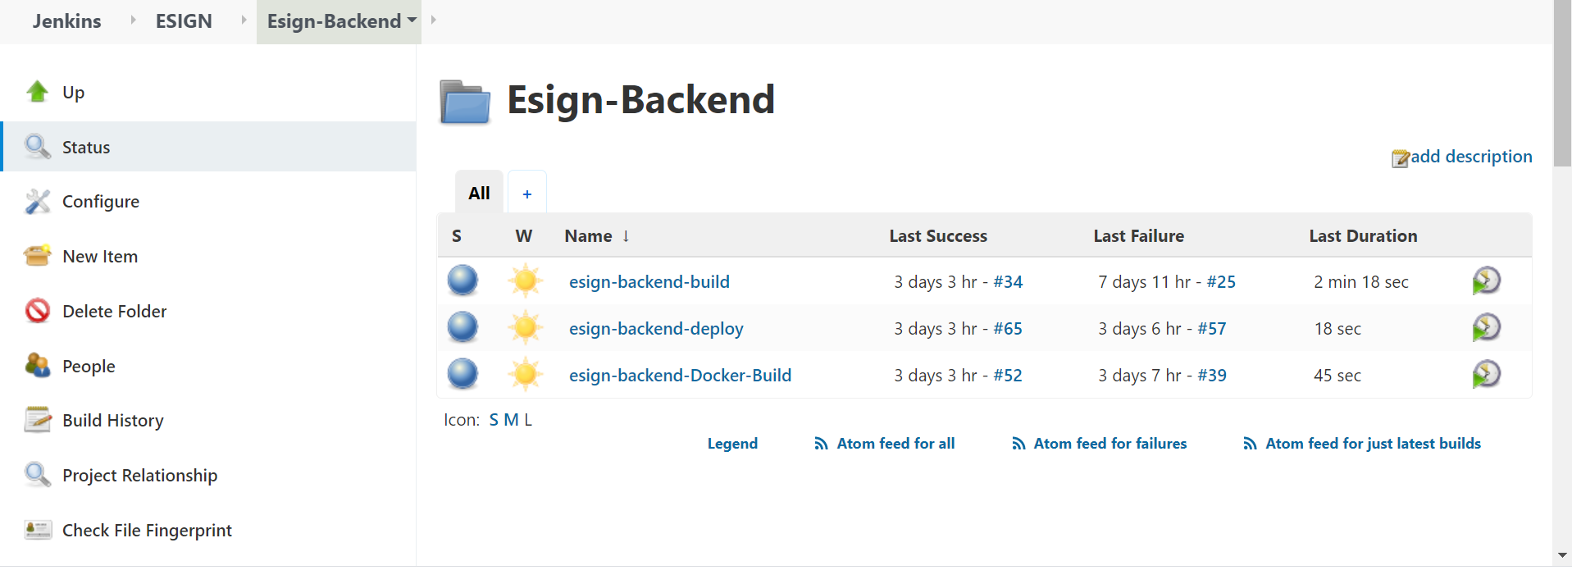

We are having three jobs, if the application team committed changes to bitbucket build the [esign-backend-build](http://10.41.75.9:8095/jenkins/job/ESIGN/job/Esign-Backend/job/esign-backend-build/)

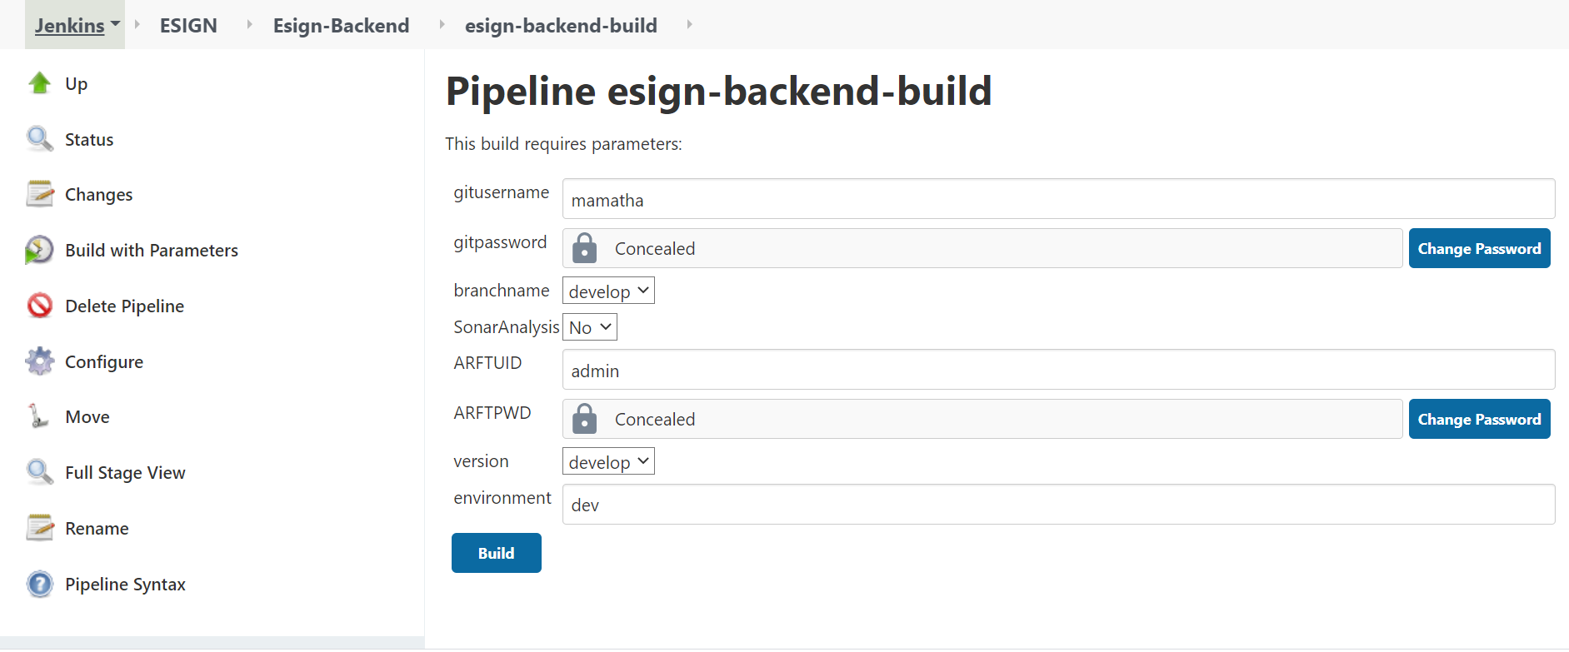

After build complete we have to see [esign-backend-Docker-Build](http://10.41.75.9:8095/jenkins/job/ESIGN/job/Esign-Backend/job/esign-backend-Docker-Build/) console log to check it build without any issue.

Same we have to check console log for [esign-backend-deploy](http://10.41.75.9:8095/jenkins/job/ESIGN/job/Esign-Backend/job/esign-backend-deploy/) . For deploy job we have see below status in console log

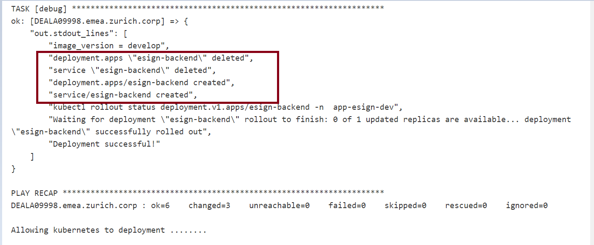

We have to check here is pod deleted and created, trigger deploy job once again ,still same than check docker build job console log is image build correctly or not .